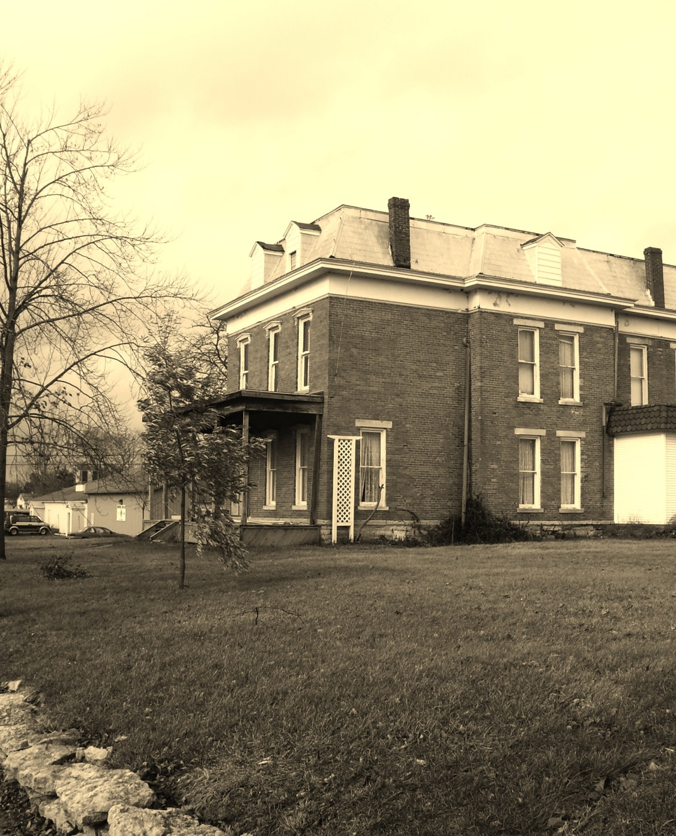

“But why!?”
”Because Aunt Nance is getting married to a banker, and when you get married to someone like that you have a nice dinner for the rehearsal, and you get dressed up for nice dinners.”
“Be a lot nicer if I didn’t have to get dressed up…”
“Well, we are going to The Old Brick House and it is a nice restaurant, so you are going to look nice”.
“Nice” served as my mother’s utility word; her go-to word for anything elevated for which the adult vocabulary was beyond what she thought was my reach. My uncle, Jerry, called The Old Brick House “classy,” and said the only reason we were going there was so my uncle-to-be’s father wouldn’t think his son was marrying too far down. In retrospect, he was probably right. This meal was an exercise in social climbing, in more ways than one.
As we climbed out of the car, I was still pouting, unbecoming to a thirteen year old, but I thought we could have walked the short five blocks from our house to the culinary landmark, but my mom told me that wouldn’t be as “nice.” Apparently crowding me, my brother, and my steps (father and three brothers) into the wood-paneled station wagon and getting a spit-bath accompanied by a lecture on her expectations of our behavior in public constituted nice.
The huge brick building towered behind a heavy Victorian barricade of stacked limestone crowned by a wrought iron fence topped by threatening spear points, shrubbery and perennials. What were they protecting the establishment from? The Proles? Each planting was carefully planned so that the visitor was bombarded with a fresh burst of color, regardless of the time of year. Even in mid-winter, the landscaping was impressive. Newly shoveled paths invited waiting guests to stone benches sheltered by arbors hollies and firs and padded with cushions to make even their cold seats…nice.
My mother insisted that my step father offer her his arm. My little brother was to take charge of our youngest two step brothers, while the oldest, Chuck, was my responsibility. We looked like the junior brigade from Solid Gold in our polyester leisure suits and platform shoes. Through that wordless language that only mothers and wives seem to speak, she let me know that any unacceptable behavior on any of my step-brothers’ parts was to be dealt with as swiftly and, of course, nicely as possible. Control seemed to be the order of the evening, and she would maintain it directly or indirectly in one way of another. There were people to be impressed and we would impress. She took one more go at straightening my little brother’s hair with my pocket comb. Walking up the concrete walk we looked…nice, if in this case it meant ready for a disco funeral.
The maître de met us at the huge oak door inlaid with an oval of stained glass. I had never been to a restaurant with a maître de before. He scared me. I thought he looked like a cross between a minister and a principal or some other authority figure that I didn’t want to get mixed up with. I had only been to a couple of restaurants with hostesses and waitresses that came to your table. To me going out meant the Castle Room at Pizza King with its black lighting that made everything glow and they served the orange sherbet with a flaming cube of sugar on top. Now, that was class.
He asked my step-father if we had a reservation, and my mother replied, “Reese, we’re with the wedding party.”
“Very good…this way” he led us under a crystal chandelier and to a narrow staircase of black mahogany that was covered with a Victorian runner. We followed, none of us breaking formation. I followed the intimidatingly formal man, forcing my unwilling escort in front of me. My step-father in his chocolate polyester and imitation peach silk straight jacket and my mother in matching peach came next. My little brother shepherded his charges. As we re-assembled and re-aligned, “Mr. and Mrs. Reese and [cough] children.” Suddenly I was very sure that I should have pressed to stay with my other grandparents.
“Good, now we can eat” My uncle, Jerry, “Bear” to me, was always the pragmatist. As I would later learn, being nice loses its power during your late teen years.
The father of the bride gave him a pained look and told the maître de that we were ready to be served. A woman I could have sworn I did not know appeared and said, “You boys will be better off with Grandma E. That way your parents can talk.” Grandma E was my name for my father’s mother whose last name was actually Durnil; my parents tried to get me to say “Reese” and all that came out was “E.”IT WAS HER! I am certain that this was the first time I ever saw my grandmother in full hair and makeup, let alone high heels.

